

Air University Aerospace and Aviation campus Kamra

Submitted by:
Muhammad Shahram Tariq
Submitted to:

MAM RUBAB
Registration No:
245320
Department:
SOFTWARE ENGINEERING
Subject:
PROGRAM FUNDAMENTAL
Date:20/dec 2024

QUESTION NO ::01

CODE ::

#include<iostream>
using namespace std;
float sum_of_pointer(float& x,float& y,float& z)
{
float sum;
float *ptr=&x;
float *ptr1=&y;
float *ptr2=&z;

sum=*ptr+*ptr+*ptr2;
return sum;
}

int main()
{
float x,y,z;
cout<<"enter first value :";
cin>>x;

cout<<"enter second value :";
cin>>y;

cout<<"enter third value :";
cin>>z;
cout<<endl;
cout<<"Sum of pointer variables :"<<sum_of_pointer(x,y,z);
}

Output ::

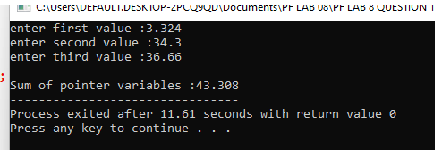

QUESTION NO :: 02

CODE ::
#include<iostream>
using namespace std;
void pointer(int& x,float& y)
{
float sum;
int*ptr=&x;
float *ptr1=&y;
cout<<"values of variables"<<endl;
cout<<"value of x : "<<*ptr<<endl;

cout<<"Value of y : "<<*ptr1<<endl;

cout<<"Address "<<endl;
cout<<"Address of x : "<<ptr<<endl;
cout<<"Address of y : "<<ptr1<<endl;

}
int main()
{
int x;
float y;
cout<<"enter value of x :";
cin>>x;
cout<<"enter value of y :";
cin>>y;
pointer( x,y);
return 0;

}

output ::

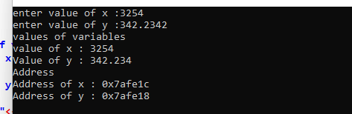

QUESTION NO ::03

code ::

#include<iostream>
using namespace std;
void arraypointer()
{
int array[5]={2,4,4,3,4};
int *ptr=array;
for(int i=0;i<5;i++)
{
cout<<"Value at array loaction : "<<i<<" = "<<*ptr+i<<endl;
}
// also if location is need to print only write ptr;
}

int main()
{
arraypointer();
return 0;
}

output ::

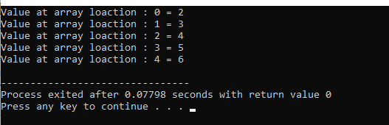

Question no ::04

Code ::

#include <iostream>
using namespace std;

void array(int* arr, int size) {
for (int i=0; i<size;++i) {
cout<<*(arr + i);
cout<<endl;
}
}

void addfunc(int* arr, int size) {
for (int i=0; i<size;++i) {
*(arr + i)+=10;
}
}

int main() {
int arr[]={15, 25, 30, 64, 85};
int size=sizeof(arr[0]);

cout<<"before adding 10: ";
array(arr,size);

addfunc(arr,size);

cout<<"adding 10: ";
array(arr, size);

return 0;
}

Output ::
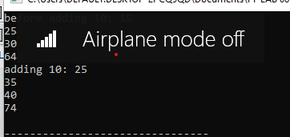

Question no ::05

Code ::

#include<iostream>
using namespace std;
int lenght(char *mystr)
{
char *ptr=mystr;
int stringlenght =0;
while(*ptr!='\0')
{
stringlenght++;
ptr++;
}
return stringlenght;
}

int main()
{
char arrstring[]="Shahram khan";
int stringlenght=lenght(arrstring);
cout<<lenght(arrstring);
return 0;
}

Output ::
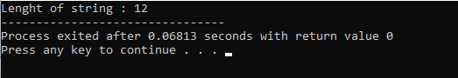

Question no ::06

Code ::
#include<iostream>
using namespace std;
void swap_function(int& x,int& y)
{
int temp;
temp=x;
x=y;
y=temp;

}

int main()
{
int x=21,y=65;
cout<<"value of x before :"<<x<<endl;
cout<<"value fo y before :"<<y<<endl;
swap_function(x,y);
cout<<"value of x before :"<<x<<endl;
cout<<"value fo y before :"<<y<<endl;
cout<<x;
return 0;
}

Output ::
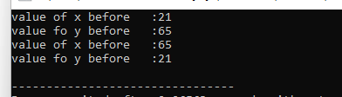

Question no ::07

Code ::
#include <iostream>
#include<string>
using namespace std;
void fruitname()
{
string arrname[4] = {"Apple", "date", "banana", "mango"};
string* ptr= arrname;
for (int i = 0; i < 4; i++) {
cout<<"Fruit NAMES : "<<*(arrname+i)<<endl;
}
}
int main() {

fruitname();
return 0;
}

Ouput ::
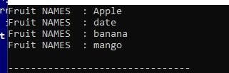

Question no ::08

Code ::
#include <iostream>

using namespace std;

struct temp {
float fahren;
float celsius;
};

void temperature(temp *tp) {
tp->celsius=(tp->fahren - 32) *5/9;
cout<<"fahrenheit: "<<tp->fahren<<endl;
cout<<" celsius: "<<tp->celsius<<endl;
}

int main()
{

temp tp;
cout<<"Eneter temperature in fahrenhiet :";
cin>>tp.fahren ;

temperature(&tp);
return 0;
}

Ouput ::
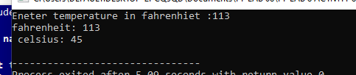

Question no ::09

Code ::
#include <iostream>
#include<string>
using namespace std;
void My_func()
{
string arrname[4] = {"Apple", "date", "banana", "mango"};
string* ptr= arrname;
for (int i = 0; i < 4; i++) {
cout<<"Fruit NAMES : "<<*(arrname+i)<<endl;
}
}
int main() {

My_func();
return 0;
}

Ouput ::
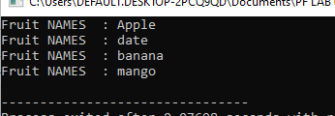

Question no ::10

Code ::
#include <iostream>
#include <string>

using namespace std;

struct temp {
float fahren;
float celsius;
};

void temperature(temp *tp)
{
tp->celsius = (tp->fahren - 32)*5/9;
cout<<"fahrenheit: "<<tp->fahren << endl;
cout<<"celsius: "<<tp->celsius << endl;
}

void myfunc(string (&arrname)[4]) {
cout << "fruit names:"<<endl;
for (int i = 0; i < 4; i++) {
cout << arrname[i] << endl;
}
}

int main()
{
temp tp;
cout<<"Enter temperature in fahrenheit: ";
cin>>tp.fahren;
temperature(&tp);

string arrname[4] = {"apple","date","banana","mango"};
myfunc(arrname);

return 0;
}

Ouput ::

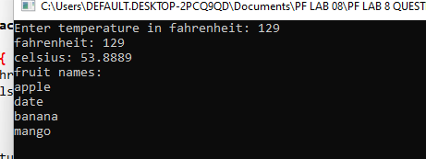

Question no ::11

Code ::
#include <iostream>
#include <cstring>

using namespace std;

const int students=100;

void inputdata(char (*name)[50], int *score,int &index) {
cout << "enter the number of student : ";
cin >>index;

for (int i=0;i<index;i++)
{
cout<<"enter name of student " <<i + 1<<": ";
cin>>name[i];
cout<<endl;
cout<<"Enter score of student "<<i + 1<<": ";
cin >> score[i];
}
}

void displayStudents(char (*name)[50], int *score, int index) {
cout << ":: Student Names and Scores ::";
for (int i = 0; i <index; i++) {
cout<<"Name: "<<name[i]<<" Score: "<<score[i]<<endl;
}
}

void highestscore(char (*name)[50], int *score, int index) {
int highestScore=score[0];
for (int i=0;i<index;i++) {
if (score[i]>highestScore) {
highestScore =score[i];
cout<<"Highest Score : "<<highestScore<<endl;
cout<<"name of highest score student :"<<name[i]<<endl;
}
}

}

double Averagescore(int *score, int index) {
float avg;
int totalscore =0;
for (int i=0;i<index;i++) {
totalscore += score[i];
}
avg =totalscore/index;
return avg;
}

void search_name(char (*name)[50],int *score,int index) {
char searchname[50];
cout << "Enter the name of the student to search: ";
cin >> searchname;

for (int i=0;i<index;i++) {
if(name[i]== searchname) {
cout<<"Score of "<<name[i]<<": "<<score[i]<<endl;
return;
}
}
cout << "Student not found!" << endl;
}

int main() {
char name[students][50];
int score[students];
int index;

inputdata(name, score, index);
displayStudents(name,score,index);
highestscore(name,score,index);

cout<<"Average Score: "<<Averagescore(score, index)<<endl;
search_name(name, score,index);

return 0;
}

Output ::

